**Sporty Shoes Flow Chart (Spring Boot Project)**

As we or client fire localjost: 8081/ > home.html page

Client request to >>>>>by html pages>>>> ShoeController with help of html pages > ShoeController request to ShoeService layer wich will be extending JPArepository which will be collecting data from client with help of ShoeEntity Class and send to again ShoeService layer. ShoeService will connect with database with help of application.properties and store data and to get **Data collect information case** ShoeService will request to model Object and model object will request to data base and collect required data in object form and return to service layer and service layer send data to ShoeController and ShoeController send data to client with help of index.html page

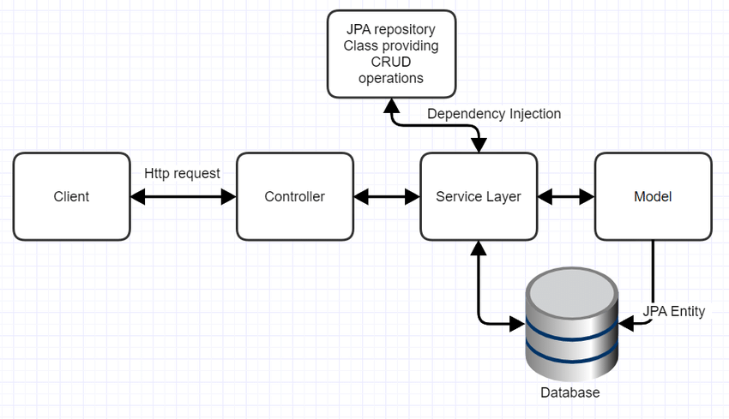

This is how Projects will look like

